LEAP (Literary Exploration Assessment Project)
Group presentation including both individual elements and group elements

Products:
- 20 minute organized presentation to class (may happen at lunch)
WITH
2) “Mind map” visual – on butcher paper or posterboard/presentation format, sized: at least 2 feet by 5 feet, with lettering large enough for the entire class to see

Goal:
- create a 20 minute presentation for the class that provides an:
  - introduction of your book
  - very short summary (overview) of the plot, characters, etc. which captures the main plot events and the essence of the story
  - themes and deeper meanings—identified, explained, analyzed
  - symbols, images, motifs— identified, explained, analyzed
  - Insightful, analytical discussion of characters and their development
  - Thorough description of setting, including time and place AND CONTEXT – when the book was written and published
  - Description of narrator’s style/voice, including elements like word choice and sentence structure, figurative language, etc. (explain the mind map to the class)
  - Explanation of critics perceptions and reactions to the book
( see the expectations outlined in the rubric.)
  - Together, use the independent projects below (and from the 8 book meetings) to help you create the analysis and the mind map visual and to create an organized presentation for the class.
- Use note-cards and your visual to keep you on track during your presentation.

Objective – these exercises are not meant to force you to make up mysterious elements that were not in your book, they are simply asking you to go back to your book and look more closely at what the author’s purpose or message, and what tools she or he used to get that message across.

For example: one of the messages that Barbara Ehrenreich meant to convey in the book Nickel and Dimed was that it is very difficult to live below the poverty line in the U.S., that it is not only the position of those who are uneducated or lacking some sort of drive to better themselves, but that people can get stuck in low income situations and have great difficulty getting out.

Her audience (the group of people who were her assumed readers) was a skeptical public, people who believed that all people in poverty somehow asked for, or deserved the positions they were in and did not deserve anyone’s help getting out of poverty and into better working and living situations.

One of the stylistic methods that she used to convey her particular message to the audience was irony and sarcasm. She often made statements that echoed the opinions in the press or in middle and higher income social circles, but made them sarcastically and followed the statements with examples of why the low-income workers did not fit the convenient stereotypes.

Your task is to demystify these elements for your listeners, to help them understand what you read and the ways that your writer used writing style to communicate with you, the reader.

- INDIVIDUAL ELEMENTS OF CULMINATING PROJECT
50 points: Each person in your group must choose ONE of the following (which will be added to the presentation and the Mind Map):

- Required for each group: Research the time period during which the book was researched, written, and published. What was happening socially? What was happening politically, both in the U.S. and the world? Was there a political movement that the book was reacting to? (For example, in the time period in which The Spirit Catches You and You Fall Down was written, was there a particular interest in immigration into the U.S.? Were there problems with communicating differences in culture for those in social services, medicine, and/or education?) What is “common” or mainstream culture like during the period included in the book? What are the social mores (ex: is divorce “normal?” “What are the expectations for education – do most people graduate from high school or college?”)

- Required for each group: Analyze the main characters in the book. How does the writer introduce them? What are they like? Are they characters you can sympathize with? Why? Why not? What does the writer do that builds or destroys sympathy in the reader? How does the portrayal of the character change throughout the text? Why and how do you believe the writer affects your feelings about the character or affects the portrayal of the character?

- Required for each group: Look closely at the literary and stylistic elements in the book: did the writer use figurative language? Find examples of symbolism (recurring throughout the book), metaphor, simile, analogy, synecdoche, imagery, themes, alliteration, consonance, assonance. Look for stylistic tools like rhetorical questions. Determine the point of view of the text: first person, third person, or second person; what purpose did the POV serve?

- Put on a Socratic Dialogue about your book. To host the dialogue you must have a list of the themes or important topics from the book (similar to the list on the Crucible anticipation guide). The themes will serve as options for the dialogue topic. You will play host, meaning that you will make sure that there is appropriate “wait time” for other students to think, make sure that every student speaks during the course of the dialogue, and make sure that no student(s) dominate the conversation. Figure out a way to keep track of who talks, set up guidelines for speaking (e.g. every comment should be connected to…., comments should build on the comments of others, comments should include references to what other students, or texts say about the topic…)

- Create a list of resources (articles and books) that fit your book. The product will be an annotated bibliography, including the title and author of the resource, publication date, a short summary of it, and an explanation of its connection to the text that you read. For example, if you read The Crucible, you might include articles analyzing the effectiveness of the play or books about the Red Scare, McCarthy, The Salem Witch Trials, Arthur Miller, etc. You should have a list of no fewer than 5 books, no more than 10.

- Sell It. Student pretends to be a publicist for the book that's just been read. The student writes and then delivers a 60-second speech that will persuade other students that they should read the book. Writing and speaking persuasively will be especially difficult if the student didn't like the book. If that's the case, the student can share that fact after completing the speech.

II. GROUP ELEMENTS OF CULMINATING PROJECT
All members of each group should complete the following two steps together as part of your final book meeting OR when meeting outside of class.

Step 1: Do a “SOAPSTone” analysis of the book. This was what you practiced in your summer reading assignment, and we have been practicing individual elements throughout the first semester:

Give one or two examples for each item, or supporting your interpretation of each item, making sure that you record where they come from within the text and what your interpretation is, or how the writer’s choices. This particular organizer was designed for a one paragraph article, so you will want to give yourself much more space to write. The following is an example created for Nickel and Dimed by Barbara Ehrenreich.
(Adapted from the College Board’s Building Success manual)

Subject: __the working poor in the United States during the late 1990’s _____

Occasion: _the Welfare program is about to change, people will only be allowed benefits for a short amount of time. People in opposition of the change believe that those who are welfare will make less money actually working minimum wage jobs than they would make on Welfare (a weakness in either the Welfare system, or in the minimum wage). People who want the laws to pass believe that a large percentage of people on Welfare or food stamps are simply taking advantage of a the government, and should be forced to take care of themselves, rather than relying on the American taxpayer to support them. The term “Welfare Mother” came up a lot during this time period.

Audience: __Those who want more information about whether the “working poor” can really make it on minimum wage. Some may be people who support the Welfare reform; some may be people who don’t. ________

Purpose: __ Ehrenreich’s regular editor (for news and magazine articles) is connected to a “liberal” publication, therefore, one might argue that there is potential bias and that Ehrenreich sets out to prove that the working poor can not support themselves because the “minimum wage” is not really a “living wage.”

Speaker: ___________________________...

TONE: explain the tone using the elements below to support your conclusions. There may certainly be more than one tone within a novel-length piece of writing.
Imagery: we talked about these items as we read Nickel and Dimed. Please make an appointment or ask outside of class if you would like to be reminded of examples – also see the paragraph that introduces the Independent book – culminating project assignment.
Details:
Diction:
Language: As in figurative language elements
Syntax:
Structure:

Step 2: You will create a “mind map” see the directions for Mind Map

Mind Mapping the Rhetorical Situation
For the last part of your culminating assignment, go back to your book and consider the rhetorical situation. Create a Mind Map that shows the relationships between the claim the author makes, the context in which the book was written or published, and all of the different SOAPSTone elements and rhetorical appeals (ethos, pathos, logos) in the text.

Mind Maps are simply graphic representations of big ideas. You might also think of them as webs or clouds.
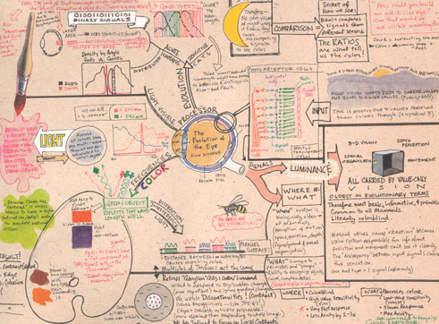

Clapp, John. “How the Eye Works.” Mindmappingstrategies.com. 12 August 2010. Web. 2009.
<http://www.mindmappingstrategies.com/mind-maps.aspx>
- First, determine the claim, or one of the claims, being made in your book: what is the essential question raised or point made in the text. For example, in The Color of Water, the claim might be that children who grow up in poverty-stricken families may still have the ability to overcome their circumstances, pursue education, and achieve personal success.

In the center of your mind map, choose an object or a symbol that represents the claim made in your book. For example, a map of Three Cups of Tea might be best centered around a tea cup or a mountain or a school. A map of Nickel and Dimed might be best centered around a paycheck or a motel or a cash register.

- From the center, create a branch for each of the rhetorical and SOAPSTone elements (Checklist on page 6). How does the author present him or herself to the reader? What is his or her intention/purpose in writing this book? What do we need to know about the context (time period, setting, political or social climate) of when the book was written or when the book takes place? Be thorough and specific. The one-word answers shown in the second example are insufficient.

- Ethos, Pathos, Logos: How does the author establish his credibility? Through research? Personal experience? Assume you are the target audience: which specific events affected you emotionally? What logical conclusions does the author arrive at based on the events in the text or the information presented?

- For each branch, give at least one piece of text evidence and explain your thinking. You can also decorate your mind map with visuals that help further your point about the book. The second example has good visual illustrations of the topic, but because it’s for a business strategy, the explanations on each branch are not sufficient for our purpose.

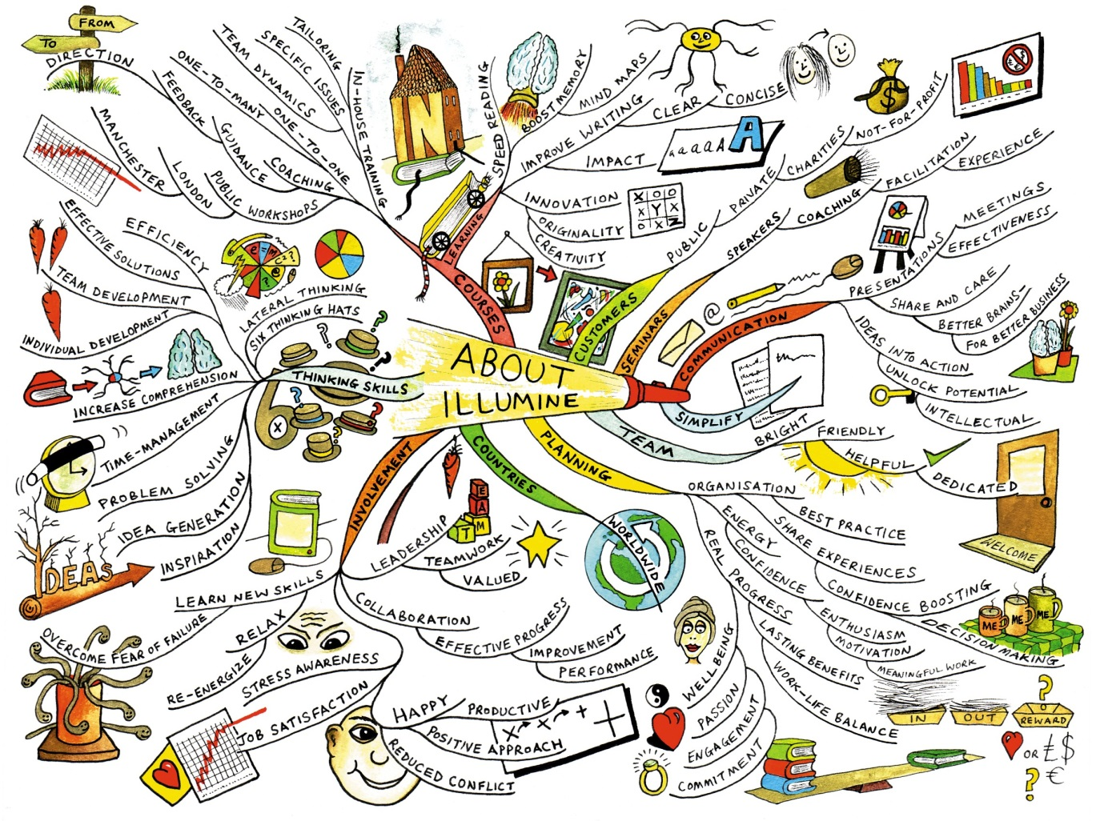
Forman, Paul. “Illumine Mind Map.” Illumine Training. 12 August 2010. Web. 2010. <http://www.mind-
mapping.co.uk/_images/_Images/EXAMPLES/BUSINESS/Company-Overviews/About-Illumine_illumine.jpg>

Mind Maps are due on the presentation day of the independent reading calendar and will count as a test grade. If you are not sure what do for this assignment or you need help with your book, speak to me before the due date. After the due date, you will be penalized 10 points for every day your map is late. After four days, you will receive a zero.
ELEMENTS THAT MUST BE INCLUDED IN YOUR MIND MAP on the next page:
ELEMENTS THAT MUST BE INCLUDED IN YOUR MIND MAP
- Claim: what is the essential question raised or point made in the text.
“SOAPS”
- Subject: subject the writer is describing
- Occasion: (this is context: time period, setting, political or social climate, what do we need to know about the historical time period in which the book was written or set?)
- Audience: who might the text be written for? Who might it convince? Who is likely to read it?
- Purpose: why was the book written? What is the writer’s purpose? This is most likely connected to the claim.
- Speaker: who is the writer portraying? What is his or her persona in the book?
- Speaker’s Attitude or TONE
Speaker’s Style:
- Imagery – These are the descriptive details that were used by the writer. You must learn to understand the reasons why the writer selected the details in the writing. Do the details create a certain atmosphere or mood?
  - Usually, imagery is carefully controlled by the writer to convey a consistent tone. For example, if I wanted to convey how much I hated something, I would only use negative details to describe it. These negative details would make my hated clear to the reader. Pay attention to the details which are used. Try to see what unifies them and why they were selected.
- Diction – This refers to the words which are used by the writer in his writing. There are many words in the English language which are highly connotative—that is, they have meanings and associations which go beyond the literal definitions. For example, look at the following list of words which essentially describe the same thing (beauty) and see how the words differ in their connotative meaning: lovely, attractive, cute, beautiful, hot, pretty, sexy. Usually, the diction helps the writer to convey his tone clearly. Learn to distinguish which words are used by the writer to make his tone clear.
- Syntax – This refers to the sentence structures present in a piece of writing. Some common syntactical features which are used by writers include repetition and parallel structure. The use of a short sentence can emphasize a point clearly, while a long sentence can be used to delay or obscure the main point. A good writer uses different syntactical strategies to convey his tone clearly.
- Structure – This is a term which covers a broad category of devices a writer can use to manipulate his writing.
  - Structure includes such things as organization, arrangement of ideas, point of view used, genre(s) of writing used, tools like dialogue, footnotes, etc.
- Ethos
- Pathos
- Logos

Presentation Scoring Rubric
 | Score | Comments
[Presentation]
Effective use of time – 20 minutes | 0 1 2 3 4 5
Well-organized (flows smoothly, pieces fit together)/Evidence of preparation | 0 1 2 3 4 5
All members speak/take an active role | 0 1 2 3 4 5
Appropriate and Effective use of presentation aides during presentation (mind map, etc.) | 0 1 2 3 4 5
[Personal: Verbal and Non-verbal]
Confidence: Posture/Stance/Gestures | 0 1 2 3 4 5
Confidence: Eye contact | 0 1 2 3 4 5
Volume/Voice projection/Lively delivery | 0 1 2 3 4 5
Professional language | 0 1 2 3 4 5
Minimal use of vocal non-fluencies (e.g. “like,” “um”) | 0 1 2 3 4 5
Effective use of personal note cards | 0 1 2 3 4 5
[Content]
Introduction/Beginning provides direction/sets tone for presentation | 0 1 2 3 4 5
Short summary captures subject/topic, main plot events and the essence of the story | 0 1 2 3 4 5
Short explanation of occasion- the context within which it was written or published, include Audience | 0 1 2 3 4 5
Short explanation of purpose and persona author adopts, and why she/he chose the persona | 0 1 2 3 4 5
Short explanation of inferred audience at the time the book was written, how and why you identify it | 0 1 2 3 4 5
Themes and deeper meanings are clearly identified, explained and analyzed | 0 1 2 3 4 5
Symbols, images and motifs are clearly identified, explained and analyzed | 0 1 2 3 4 5
Insightful, analytical discussion of characters and their development | 0 1 2 3 4 5
Description of setting, including time and place | 0 1 2 3 4 5
Description of narrator’s style/voice (includes brief examples or explanation of structure, imagery, diction, syntax, appeals) | 0 1 2 3 4 5
 | TOTAL: _________/100

Mind Map Scoring Rubric
 | Score
VISUAL: well organized, appealing | 0 6 12.5 19 25
VISUAL: central image/object which symbolizes main claim | 0 6 12.5 19 25
Claim: what is the essential question raised or point made in the text. | 0 5 10 15 20
“SOAPStone”
Subject: subject the writer is describing | 0 1 2 3 4 5 6 7 8 9 10
Occasion: explanation, including research to support. (this is context: time period, setting, political or social climate, what do we need to know about the historical time period in which the book was written or set?) | 0 1 2 3 4 5 6 7 8 9 10
Audience: who might the text be written for? Who might it convince? Who is likely to read it? | 0 1 2 3 4 5 6 7 8 9 10
Purpose: why was the book written? What is the writer’s purpose? Most likely connected to the claim. | 0 1 2 3 4 5 6 7 8 9 10
Speaker: who is the writer portraying? What is his or her persona in the book? | 0 1 2 3 4 5 6 7 8 9 10
Speaker’s Attitude or TONE - with examples and short explanation or label | 0 1 2 3 4 5 6 7 8 9 10
Speaker’s Style:
Imagery – with examples and short explanation or label. Include what mood/atmosphere the details create | 0 1 2 3 4 5 6 7 8 9 10
Diction – with examples and short explanation or label | 0 1 2 3 4 5 6 7 8 9 10
Syntax – with examples and short explanation or label | 0 1 2 3 4 5 6 7 8 9 10
Structure – with explanation and page numbers | 0 1 2 3 4 5 6 7 8 9 10
Ethos – with examples and short explanation or label | 0 1 2 3 4 5 6 7 8 9 10
Pathos - with examples and short explanation or label | 0 1 2 3 4 5 6 7 8 9 10
Logos - with examples and short explanation or label | 0 1 2 3 4 5 6 7 8 9 10
TOTAL : ___________/ 200

1) a recurring subject, theme, idea, etc., especially in a literary, artistic, or musical work... 3) a dominant idea or feature. dictionary.com 11 Nov 2012:
Structure is the way the text is put together. It can include “mode” like narrative or exemplification, but also may include things like inclusion of diary entries, letters, or news articles, whether the text uses chronological order, whether the text is told in flashbacks, whether the text is told in two or more voices, alternating chapters, point of view, etc. If you are unsure, please talk with your group and talk with me outside of class hours.

