Name:
Class:
Date:

Please define the following terms:
- Utopia: _____________________________________________________________________________

- Totalitarianism: _______________________________________________________________________

- Caste System: _______________________________________________________________________

- Dystopia:____________________________________________________________________________

- Hypnopaedia: ________________________________________________________________________

Cultural and historical context of Brave New World:

- Information about Huxley:

- List three important events that had occurred soon before the publication of Brave New World.
a.

b.

c.

d.

These people had an effect on Brave New World:
- Henry Ford

- Sigmund Freud

Using the Powerpoint, please list the seven different caste levels of Brave New World, placing the elite controllers at the top of the triangle.
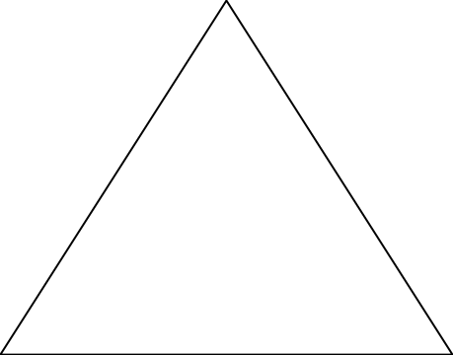

What does the “pyramid” symbolize concerning the caste system? Why use the pyramid to represent a caste system versus a rectangle, star, or any other shape?

How would a caste system benefit a country’s elite or rulers?

